9/1/2024

CMS ID: 023-23-0365

DSA LAB 02 || Submitted to ma’am marina gul

FAHEEM AKBAR

DSA Lab: 02 Solution

Task 01: Search number in Linked List

Solution:

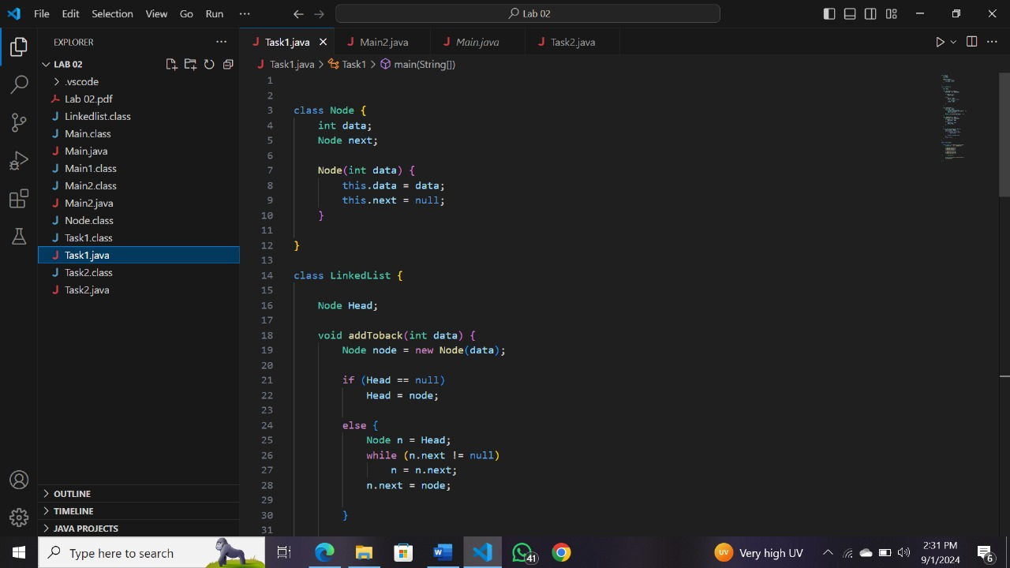

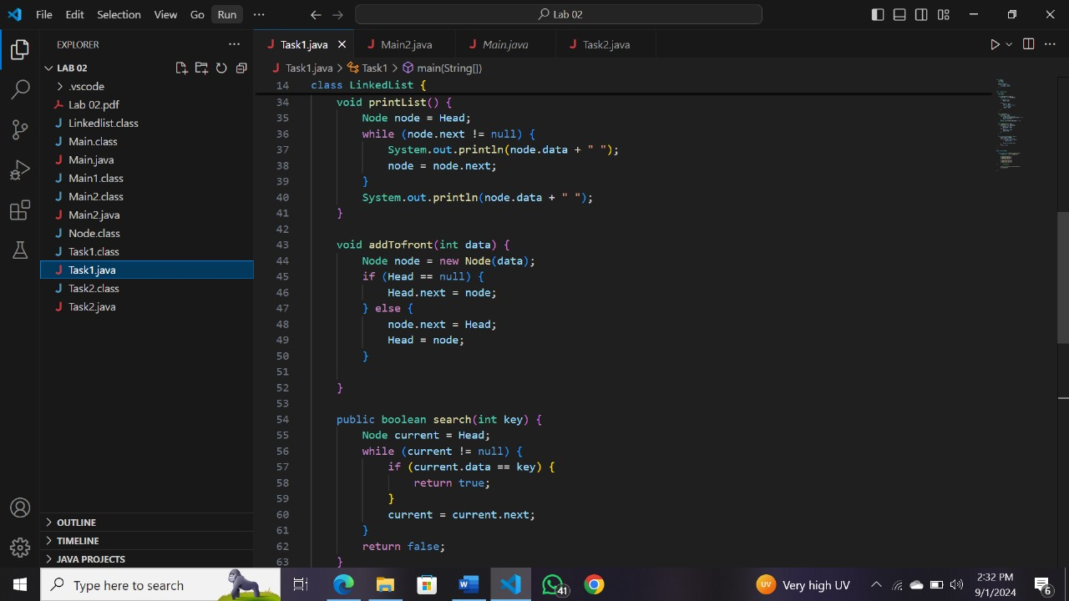

Output

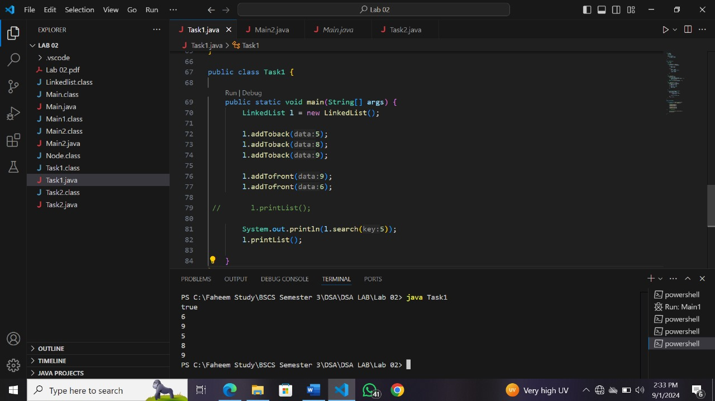

Task 2: Find length of Linked List

Solution

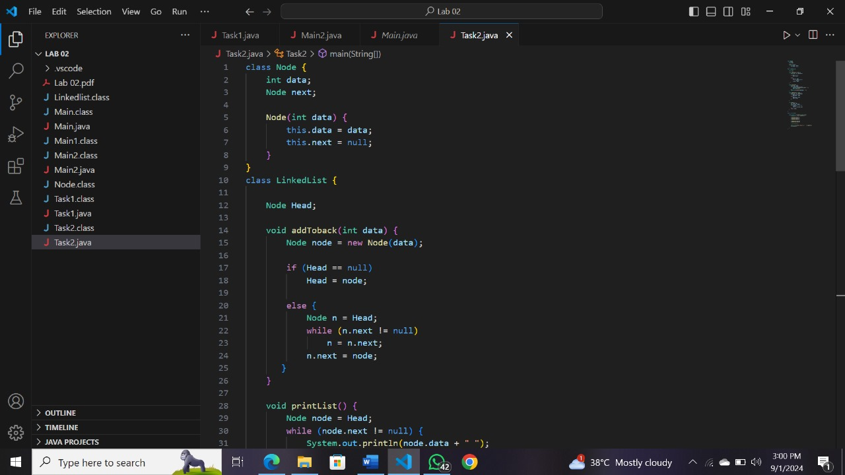

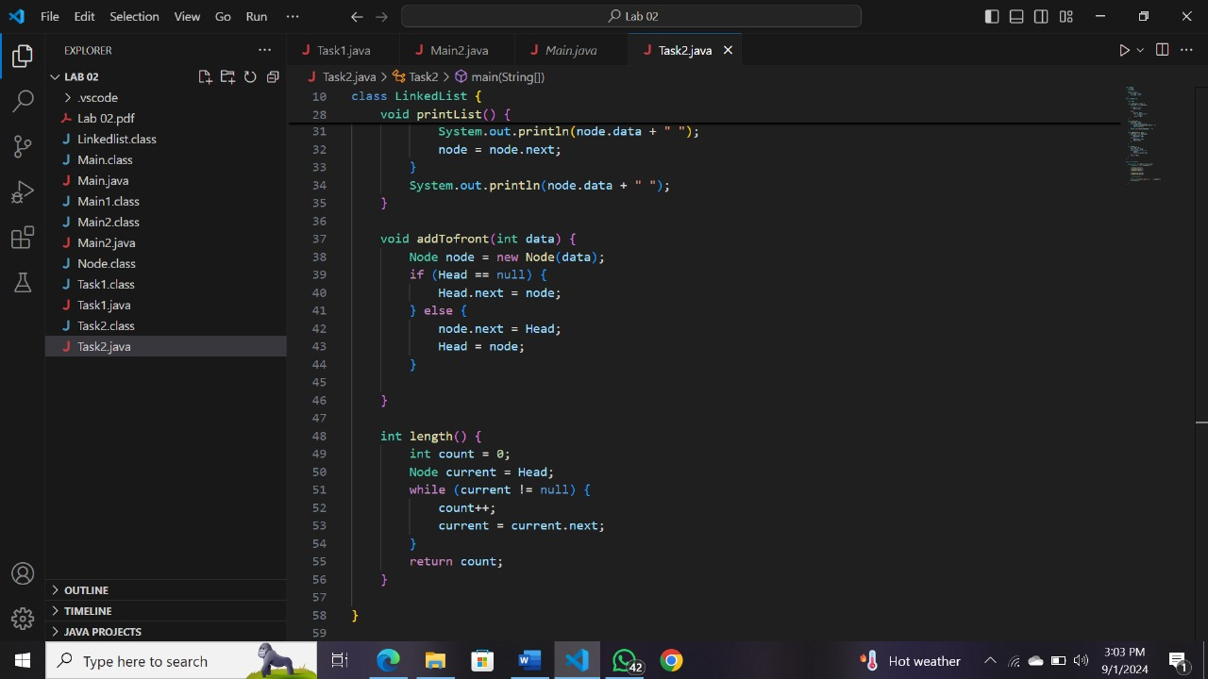

Output:

